**Using the Pratt Pouch**

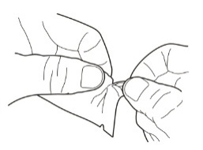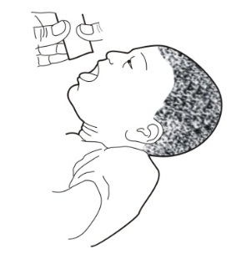**[](https://portal.intrahealth.org/Departments/Communications/Image%20Library/IntraHealth%20logo/IntraHealth%20Logo%20for%20Documents%20in%20Word%20and%20PPT.jpg)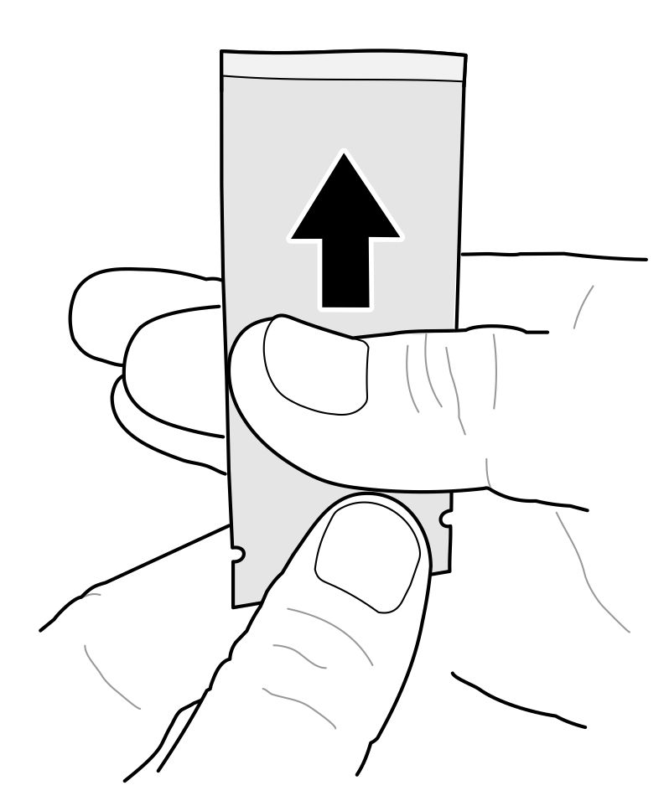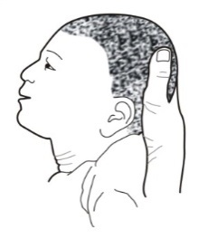[](https://portal.intrahealth.org/Departments/Communications/Image%20Library/IntraHealth%20logo/IntraHealth%20Logo%20for%20Documents%20in%20Word%20and%20PPT.jpg)[](https://portal.intrahealth.org/Departments/Communications/Image%20Library/IntraHealth%20logo/IntraHealth%20Logo%20for%20Documents%20in%20Word%20and%20PPT.jpg)******

**If baby vomits** the medicine within one hour, provide second dose.

**Return to the health center within six (6) days after delivering at home**

**If baby vomits** the medicine within one hour, provide second dose.

**Return to the health center within six (6) days after delivering at home**

**If baby vomits** the medicine within one hour, provide second dose.

**Return to the health center within six (6) days after delivering at home**

**Place** baby on his or her back.

**Wash and dry hands** well before starting process.

**Place used pouch** in “used” bag.

**Using the Pratt Pouch**

**Place** baby on his or her back.

**Wash and dry hands** well before starting process.

**Place used pouch** in “used” bag.

**Using the Pratt Pouch**

**Place used pouch** in “used” bag.

**Wash and dry hands** well before starting process.

**Place** baby on his or her back.